Northeast Algal Society Phycology Lab Manual

Lab Activity: Trophic Cascades

Developed by: Dr. Jeffery J. Law, jlaw@daemen.edu; Daemen College
Dr. Sarah B. Whorley swhorley@daemen.edu; Daemen College

Learning Objectives

By the end of this activity, students should be able to describe multiple levels of food webs, as well as compare and contrast both top-down and bottom-up food web controls.
Assessment Method
This activity is intended to be written up as a standard scientific manuscript. This provides practice with formal scientific writing, working with data and statistical analyses, as well as drawing conclusions from that data.
Instructor Notes
Materials or supplies required:
- Clear plastic cups that hold at least 200mL, 12 per team with extras for mixing algae culture when necessary
- Droppers or plastic pipettes with wide mouths, 2 per team
- Spring water, up to 2400mL per team
- Graduated Cylinders, 1 per team
- Plastic wrap (to cover all cups for the duration of the experiment)
- Organisms – a typical set up allows a group of students to mix 100mL of algae with 100mL spring water (200mL total volume) per cup. Group of students can be allowed a large total number of herbivores (e.g. 32 Daphnia) and a smaller number of predators (e.g. 16 Hydra) to be allocated among cups as their experiment allows.
  - Algae culture of Scenedesmus (from Carolina: #152510 ). You can use other microalgal cultures as your prefer. Different cultures may be used together to explore feeding preferences
  - Daphnia magna (from Carolina: #142330 ), 36 per team
  - Hydra littoralis (from Carolina: #132800 ), 16 per team

Equipment required:
- Access to Excel (or data processing software of choice)
- Spectrophotometer set to 665nm and associated supplies (for quantifying algae)
- Dissecting microscopes and associated supplies (for quantifying Daphnia and Hydra)

Techniques required (those which are not taught during the activity but students must already have a working knowledge): Microscopy skills, experimental design, data analysis
Time required: ~1 week, 2 hours each week (depending on number of samples)

Example Experimental Design: This is an example of how an experiment could be designed. Each circle represents one cup. Here, there are three treatments, each with four replicates. Algae concentration should be measured before the addition of Daphnia at the start, and again after one week.
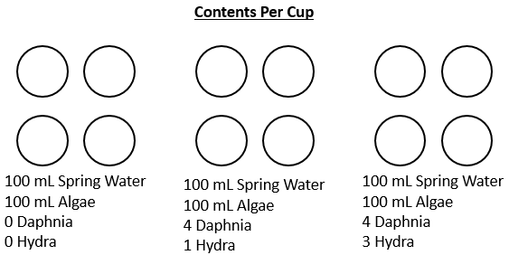
Data analysis following this experiment should include making of graphs and interpreting an ANOVA analysis. Statistics used should be appropriate for experimental set up and data collected.
An alternative experimental set up can maintain constant numbers of heterotrophs in each cup but varying the concentration of algae (e.g. 50mL, 100mL, and 150mL).
Anticipated audience: 1) intro majors course 2) upper level majors course 3) nonmajors course 4) graduate course 5) outreach

Northeast Algal Society Phycology Lab Manual

Lab Activity: Trophic Cascades

Developed by: Dr. Jeffery J. Law, jlaw@daemen.edu; Daemen College
Dr. Sarah B. Whorley swhorley@daemen.edu; Daemen College

Name: ______________________________

Objectives
- To demonstrate the control of primary production in ecosystems by higher trophic levels
- To design, execute, and interpret results from an experiment on trophic cascades
- To understand and use the appropriate statistical test.

Introduction: Primary Productivity and Food Webs
Organisms capable of producing organic molecules from sunlight and carbon dioxide in the atmosphere form the base of most food webs. Such organisms (autotrophs) provide both carbon and energy to the higher trophic levels (heterotrophs) that feed on them. Autotrophs use most of the energy they capture to fuel their daily activities- for example, their metabolism and reproduction. As a rule of thumb, only 10% of the energy captured by autotrophs is turned into tissue that can be eaten by primary consumers-those heterotrophs that feed on autotrophs. In turn, only about 10% of the energy eaten by primary consumers is available to the secondary consumers that feed on them. Energy flow between organisms is often diagrammed using a food web (Figure 1).
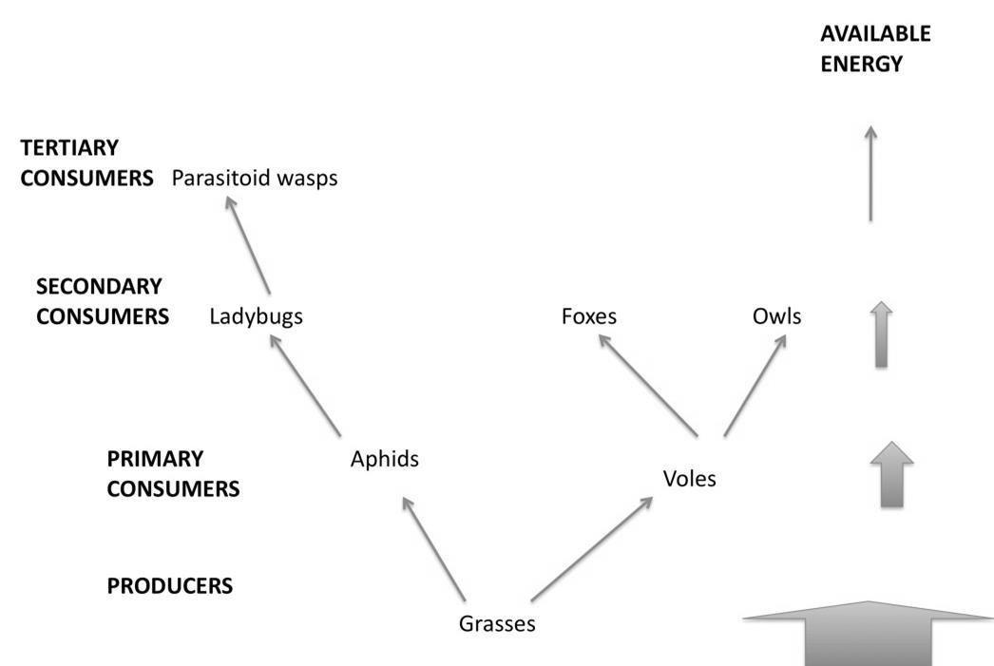
Figure 1: Simplified food web of a grassland ecosystem.

Note that although there are more types of organisms at higher trophic levels of this web, the energy available and thus the biomass of organisms decreases at higher trophic levels. Because of their position at the base of a food web, producers control the energy budget of their ecosystems.
While producers set the energy budget for their ecosystems, their own growth can be controlled in two different ways. In bottom-up control, the growth of producers is limited by their access to the resources they need to grow- sunlight, carbon dioxide, mineral nutrients. In many ecosystems, however, growth of producers is limited from the top-down- that is, producers’ growth is limited by the organisms eating them.

Top-down control can be complicated, however, by interactions with higher trophic levels. An increase in the number of secondary consumers can reduce the number of primary consumers, freeing the producers to grow more- an effect that is referred to as a trophic cascade. This cascading complexity can be seen in the diagrams below:
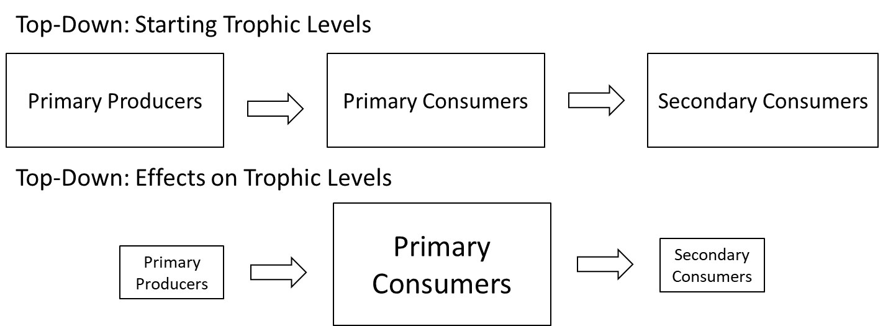

Describe in a few sentences what is occurring in the community between the first and second set of trophic levels:

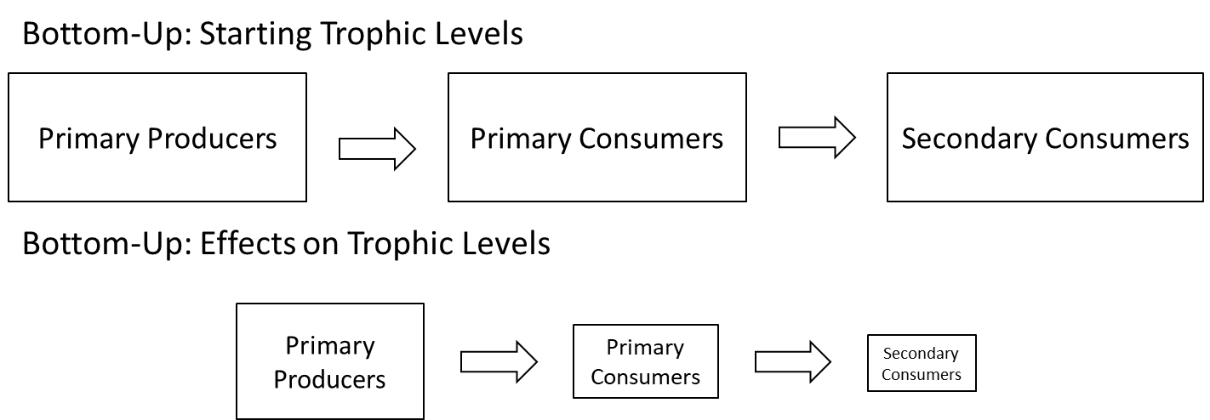

Describe in a few sentences what is occurring in the community between the first, second, and third sets of trophic levels:

In this lab, you will use a simplified aquatic food web consisting of Scenedesmus sp., Daphnia magna, and Hydra littoralis to examine the strength of top-down or bottom-up controls. Which trophic level do each of these organisms occupy?

- Primary Producer: _________________________________________________

- Primary Consumer: ________________________________________________

- Secondary Consumer: ______________________________________________

Literature:
Chose at least three (3) relevant citations from peer-reviewed journals to use in the generation of your hypothesis and predicted results.
- McIntosh, Angus R., and Colin R. Townsend. "Interactions between fish, grazing invertebrates and algae in a New Zealand stream: a trophic cascade mediated by fish-induced changes to grazer behaviour?." Oecologia 108.1 (1996): 174-181.
- Polis, Gary A., et al. "When is a trophic cascade a trophic cascade?." Trends in Ecology & Evolution 15.11 (2000): 473-475.
- Pace, M. L., Cole, J. J., Carpenter, S. R., & Kitchell, J. F. (1999). Trophic cascades revealed in diverse ecosystems. Trends in ecology & evolution, 14(12), 483-488.
- Carpenter, S. R., Kitchell, J. F., & Hodgson, J. R. (1985). Cascading trophic interactions and lake productivity. BioScience, 35(10), 634-639.
- Ramcharan, C. W., France, R. L., & McQueen, D. J. (1996). Multiple effects of planktivorous fish on algae through a pelagic trophic cascade. Canadian Journal of Fisheries and Aquatic Sciences, 53(12), 2819-2828.
- Tessier, A. J., & Woodruff, P. (2002). Cryptic trophic cascade along a gradient of lake size. Ecology, 83(5), 1263-1270.
- Khan, T. A., Wilson, M. E., & Khan, M. T. (2003). Evidence for invasive carp mediated trophic cascade in shallow lakes of western Victoria, Australia. Hydrobiologia, 506(1), 465-472.
- Vanni, M. J., & Findlay, D. L. (1990). Trophic cascades and phytoplankton community structure. Ecology, 71(3), 921-937.
- Stein, R. A., DeVries, D. R., & Dettmers, J. M. (1995). Food-web regulation by a planktivore: exploring the generality of the trophic cascade hypothesis. Canadian Journal of Fisheries and Aquatic Sciences, 52(11), 2518-2526.
- Ellis, B.K., Stanford, J.A., Goodman, D., Stafford, C.P., Gustafson, D.L., Beauchamp, D.A., Chess, D.W., Craft, J.A., Deleray, M.A. and Hansen, B.S., 2011. Long-term effects of a trophic cascade in a large lake ecosystem. Proceedings of the National Academy of Sciences, 108(3), pp.1070-1075.

Experimental Design
Your experiments must address the importance of trophic cascades in the Hydra, Daphnia, algae system. Like all scientists, you have limited resources to test your hypothesis. You can run your experiment for a maximum of one week. Your experimental unit will be a plastic cup that holds 200 mL of fluid. You may use a maximum of 36 Daphnia and 16 Hydras for your experiment. Remember that in order to perform statistical tests you will need to have replicates of each treatment. There are several dependent variables that you can measure for your assignment, including algae growth, number of Daphnia, and number of Hydra.
Your lab instructor must approve your experimental design before you can start setting up the experiment. We recommend adding 100 mL of spring water and 100 mL of algae to each cup, however you can choose to alter these amounts. Please stir the algae before you measure it with a graduated cylinder and dispense it to each cup. Use algae from the SAME bottle for all your cups or mix two bottles before. Not all bottles have algae at the same concentration. You need to rinse everything with spring water before use (NO SOAP) to keep algae and Daphnia alive.
Transfer Daphnia and Hydra with a wide-mouth bulb pipette. Place the cups where directed and cover with plastic wrap to help prevent evaporation of the water. You will need to collect data once during the next week and again during your next class period. You will need to decide what data you are collecting at each measurement period.

Quantifying Daphnia, Hydra, and Algae
Daphnia and Hydra can be counted easily. You may choose to use the dissecting scope if you wish. Algae may be quantified using a spectrophotometer. In order to capture light energy, photosynthetic organisms use a light-absorbing molecule called chlorophyll a. Chlorophyll a absorbs light well at 665 nm, so we can use a spectrophotometer to estimate algal concentration.

- Prepare a blank by filling the cuvette with 3 mL of the same spring water we used to culture the algae. Blank the spectrophotometer and read the absorbance at 665 nm.
- Immediately before sampling, cover the cup with parafilm and swirl to suspend the algae. This is crucial- algae will settle to the bottom of a cup easily, and failing to mix them will result in an underestimation of algal density.
- Immediately after mixing, transfer 3 mL of algae to a cuvette. Avoid Daphnia and Hydra, which are not present in the blank.
- Read the sample at absorbance 665 nm.
- After your incubation week, count the number of Daphnia present in each cup. You can use the dissecting scope and a Petri plate to help you keep track.
- Next, count the number of Hydra in each cup. Again, you can use a dissecting scope and a Petri plate to help keep track.

Study Proposal Form

Project Investigators: Project Title: Experimental Question:

Key Background Information:
(What would someone need to know to understand your purpose/question?)

Hypothesis (and reasoning behind it):

Experimental Design:
(Consider drawing a picture as well as a verbal description)

No. of Replicates Per Treatment:

Data To Be Collected: (including collection schedule)

Statistical Analysis: (Give the name of the test and exactly what data will be compared)

Draw a graph showing expected results that would confirm your hypothesis:

Draw a graph showing expected results that would refute your hypothesis:

Potential Confounding Variables and Ways to Control Them:

Materials Needed:

