Northeast Algal Society Phycology Lab Manual
Lab Activity: Phylogeny Building With Mobiles
Developed by: Dr. Richard M. McCourt, Academy of Natural Sciences of Drexel University
Contact: rmm45@drexel.edu

Learning Objectives
By the end of this activity, students should be able to construct and describe a phylogeny of sample specimens of animals and seaweeds using a mobile to model the phylogenetic tree (Fig. 1). They should be able to identify the parts of a phylogenetic tree and state a hypothesis represented by the tree. Using the phylogeny they construct they will be able to state verbally the hypotheses represented by the tree.
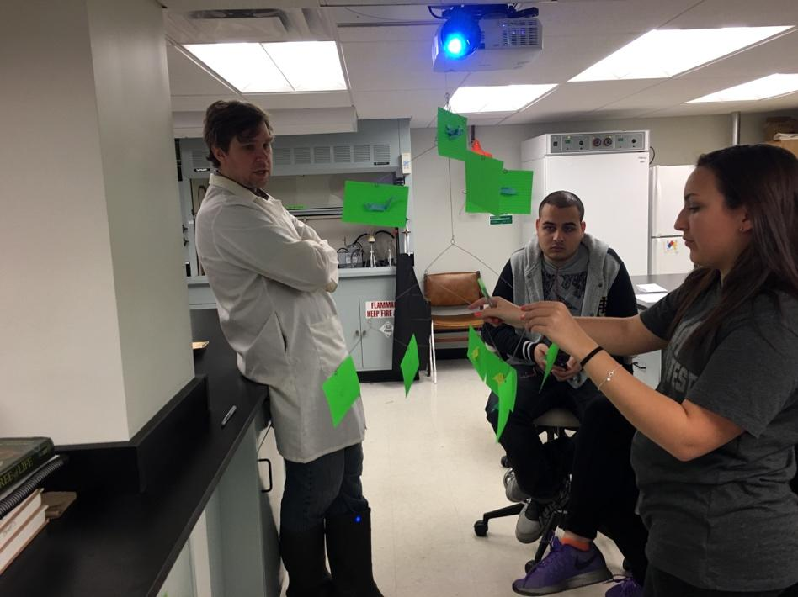
Figure 1. Students construct a phylogenetic tree using a mobile and index cards. The instructor critiques.
Assessment Method
Students will complete an answer sheet in writing and also describe to the instructors the tree they build.

Instructor Notes
Materials or supplies required: Index cards, marking pens, paper clips, and algae photos (e.g., NEAS playing cards or printouts), and mobiles, which may be obtained from art or museum stores. The one used here is called the Kikkerland RANDOM HANGING Photo and Postcard Mobile 9 picture, available on Amazon.com.
Readings: Baum, Smith, and Donovan (2005) The Tree-Thinking Challenge
Baum (2008) Reading a Phylogenetic Tree: The Meaning of Monophyletic Groups
Optional resources: Photocopies of pp. 71-73 from Phylogenetic Trees Made Easy (Hall 2011)

Equipment required: None
Techniques required (those which are not taught during the activity but students must already have a working knowledge): General knowledge of what a phylogeny represents from, for example, an introductory lecture or reading (the Baum et al. article provides some of this).

Time required: ~1 - 2 hours.

Anticipated audience: 1) intro majors course 2) upper level majors course 3) nonmajors course 4) graduate course 5) outreach

Pre-lab Assignments
Students should have read the paper by Baum et al. (2005) and Baum (2008) to familiarize themselves with phylogenetic trees and completed the pre-lab questions.

Lab Procedure
Distribute one mobile kit, sticky notes, and paperclips to each team.

After the students have labeled their mobiles and placed stickies representing each of the animals from the Baum (2005) paper, ask them questions to determine their understanding of the anatomy of the phylogenetic tree. Example questions include:
Where is a node?
Which branches are internal or tips?
Where is a polytomy represented on the tree?
Which taxa at the tips are sister taxa?

Review student answers to the first portion of the exercise. Once students have worked through the questions pertaining the animals within the Baum (2005) paper, distribute 9 seaweed photos or NEAS playing cards to each team.

Collect completed worksheets.

References
Baum, David A., Smith, Stacey DeWitt, and Donovan, Samuel S. S. 2005. Perspectives: The Tree-Thinking Challenge. Science 310:979-980.
Baum, D. (2008). Reading a phylogenetic tree: the meaning of monophyletic groups. Nature
Education, 1(1), 190.
Hall, Barry G. 2011. Phylogenetic Trees Made Easy: A How-To Manual. 4th Edition. Sinauer, Inc., Sunderland, MA. ISBN-13: 978-0878936069 ISBN-10: 0878936068

Pre-Lab Question Sheet ANSWER KEY Name: __________________________

Read: Baum, David A., Smith, Stacey DeWitt, and Donovan, Samuel S. S. 2005. Perspectives: The Tree-Thinking Challenge. Science 310:979-980.
Baum, D. (2008). Reading a phylogenetic tree: the meaning of monophyletic groups. Nature
Education, 1(1), 190.

You may discuss these questions based on the Baum et al. paper after discussion with your lab group. All answers should be IN YOUR OWN WORDS.

1. In one sentence, state what a phylogenetic tree represents.

Baum et al. say that "The preferred interpretation of a phylogenetic tree is as a depiction of lines of descent." In other words a tree depicts a hypothesis about the evolutionary history of a group of taxa.

2. What does a node on a tree represent?

From the article: "...the nodes (branching points on a tree . . . correspond to actual biological entities that existed in the past: ancestral populations or ancestral genes." The students should paraphrase or explain this in addition to any direct quotations.

3. Describe why a phylogenetic tree does not represent similarity, but instead represents historical relationships.

Two organisms may look similar but have very divergent evolutionary relationship, e.g., fish and marine mammals.

4. Draw an example of 2 trees that appear to be superficially different but actually represent the same set of phylogenetic relationships.

The trees shown in the figure in the paper are an example of this.
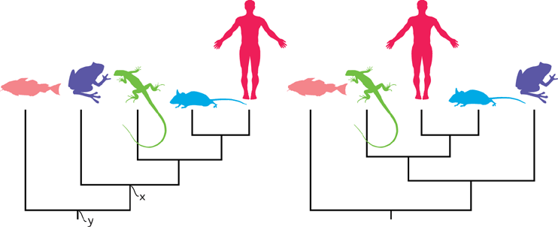
Northeast Algal Society Phycology Lab Manual
Lab Activity: Phylogeny Building With Mobiles
Developed by: Dr. Richard M. McCourt, Academy of Natural Sciences of Drexel University

Pre-Lab Question Sheet Name: __________________________

Read: Baum, David A., Smith, Stacey DeWitt, and Donovan, Samuel S. S. 2005. Perspectives: The Tree-Thinking Challenge. Science 310:979-980.
Baum, D. (2008). Reading a phylogenetic tree: the meaning of monophyletic groups. Nature
Education, 1(1), 190.

You may discuss these questions based on the Baum et al. paper after discussion with your lab group. All answers should be IN YOUR OWN WORDS.

1. In one sentence, state what a phylogenetic tree represents.

2. What does a node on a tree represent?

3. Describe why a phylogenetic tree does not represent similarity, but instead represents historical relationships.

4. Draw an example of 2 trees that appear to be superficially different but actually represent the same set of phylogenetic relationships.

Northeast Algal Society Phycology Lab Manual
Lab Activity: Phylogeny Building With Mobiles
Developed by: Dr. Richard M. McCourt, Academy of Natural Sciences of Drexel University

Phylogeny Building Worksheet Name ________________________
Before performing the lab exercise, break into groups and discuss the general idea of the articles with your group and your answers to the pre-lab questions.

- Based on the article, what is a common mistake made in interpreting phylogenetic trees? You may base this on the discussion with your group members, but do not copy each other’s writing.

- Hang an index card from each tip of the free branches on the mobile provided by your instructor. Label each card with a letter (i.e., A, B, C, etc.).

Draw a tree diagram below of the mobile you created.

3. Refer to Baum (2008) or the pages from Phylogenetic Trees Made Easy, by Hall, pp. 71-73. Define each of the following parts of your tree and label them on your diagram above.
External node—

Internal nodes—

Branches—

Polytomy—

Root—

4. Refer to the Baum et al. (2005) article provided. On sticky notes, draw a picture of each organism in the tree in their figure. Place them on the mobile by sticking them to the appropriate index card. Note that there are 5 organisms and 9 possible index cards to stick them to, so you will have some cards without stickies. You should still be able to place them correctly by assuming that an empty card is a zero-length branch on the mobile.
Draw a new diagram below, indicating the placement of animals. You will be adding to this diagram over the next few questions so be sure it is large and clear.

5. Working with your group and based on the readings and your understanding of tree-thinking, develop a hypothesis about the relationship of fish and frogs relative to frog and mouse and state it below.

6. Attach a new sticky note to the node on the tree that represents the common ancestor of the following pairs of organisms (label the sticky note with the organisms' names):

a. fish-frog
b. mouse-human
c. lizard-human
d. frog-mouse
Indicate these common ancestors on your diagram above.

7. Bifurcating is a term used to describe a branch or fork that further divides into two additional branches or forks. These mobiles were not designed for our class, so they were not meant to represent a bifurcating tree in a strict sense. In your diagram above, label a part of the phylogeny mobile that is not bifurcating with “Non Bifurcating”. Under what biological conditions would a non-bifurcating tree be an unsuitable representation of a phylogenetic history?

8. Describe a feature that is not bifurcating and suggest what it might represent in a phylogenetic tree.

9. Replace the drawings of animals with printed images or plastic cards with pictures of seaweeds on the mobile. Based on observed morphological features (e.g., color, thallus form) in the images, arrange them so that the seaweeds represent a phylogeny, that is, a hypothesis of their evolutionary relationships.
Draw the mobile phylogeny with the images and names of the seaweeds.

10. Describe the morphological similarities you used to decide which seaweeds are more closely related to each other.

