Northeast Algal Society Phycology Lab Manual
Lab Activity: Biofouling testing using Ulva cf. linza spores
Developed by: Lucie Maranda, University of Rhode Island, lmaranda@uri.edu

Learning Objectives
By the end of this activity, students should be able to 1) work with live algal material, 2) identify by microscopy and separate biflagellated Ulva spores from quadriflagellated ones, and 3) determine algal cell density, all within the context of testing the response of different materials or materials under different conditions to a biofouling challenge. Students will also be able to 4) explain and justify their experimental design, 5) compare their spore adhesion results using basic statistical tools, and 6) discuss problems that can be addressed using this Ulva biofouling approach.
This exercise partially follows the methodology used in standard preliminary assays for testing anti-fouling properties of experimental materials (Callow et al. 1997).
Ulva life history
The benthic green alga Ulva cf. linza Linnaeus is often used as a model organism for the study of the fouling process, as well as for testing the capacity of materials to resist fouling. All Ulva species alternate between sexual (gametophyte producing gametes) and asexual (sporophyte producing zoospores) stages. Although the gametophyte is haploid (1N) and the sporophyte is diploid (2N), they are morphologically similar. The zoospores are haploid as a result of meiosis; they have four flagella and settle within hours of release, thus they are the cells we look for in biofouling testing. Gametes settle only after fusion.
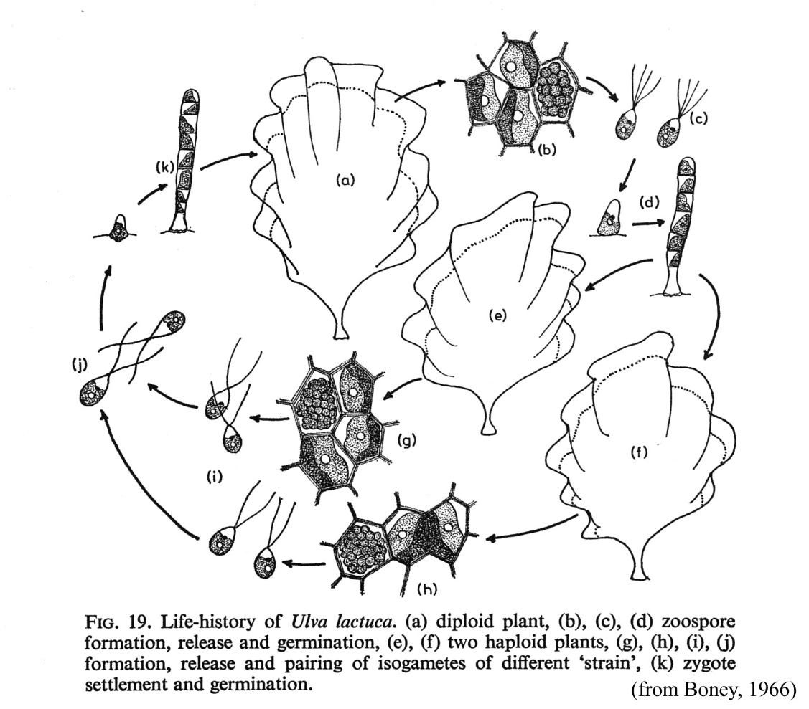
Biofouling
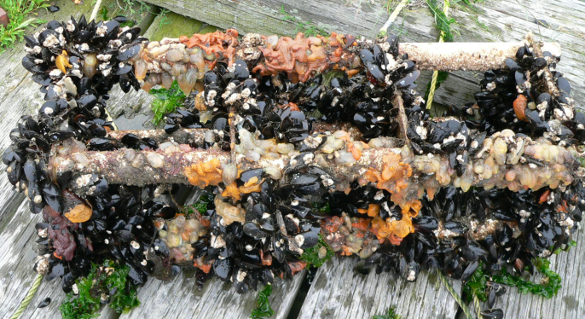
Biofouling is the (generally undesirable) accumulation of a biological community at an interface. In the marine environment, the interface is between a solid (rocks, pilings, boat hull) and seawater. This community can actually be quite productive and contribute to coastal food webs as a food source for bacterivores, herbivores, carnivores, and detritivores. However very often, it is a nuisance on man-made structures, as it may lead to damage, loss of performance, and economic losses. It all starts with the formation of a biofilm, i.e. the settlement of a living microbial community on a surface.
Hypothesis and Questions
- If you were to evaluate a commercial foul-release coating, what would be the hypothesis?
- What would be an adequate control?
- What precautions should the students consider when applying the coating?
- How should the students store the prepared samples before the adhesion experiment?
- How many replicates should be included in the experimental design to provide satisfactory results?
- What is the difference between replicates and pseudo-replicates?
Assessment Method
Students will first understand Ulva life history and demonstrate proper use of a compound microscope. If they collect specimens themselves, they will show their ability to recognize the genus, preferentially to the species level such as cf. linza with its ruffled edges, and pick fertile specimens with “ripe” edges. In the laboratory, the students will demonstrate their ability to replicate measurements of cell density using counting chambers before adhesion study, and with counting cells in given field of views after adhesion. Students will be able to enter their own data in spreadsheets, manipulate tables and charts, and use simple statistical tests for analysis. The students will concisely write a report, scientific manuscript style, where future experiments should be noted to either obtain more convincing results or expand on different materials.
Instructor Notes
Materials or supplies required:
- Fertile Ulva is required. Specimens can be collected by the instructor ahead of time or by students if time and tide permit.
- Absorbent paper (e.g., Qualitative filter paper P5, or equivalent commercial thick paper towels), glass slides with frosted end, cover slips, 15-to-50 mL glass or plastic culture tubes, filtered and sterile seawater, Lugol’s solution, crushed ice, 90-µm sieve, Quadriperm or Petri dishes, pipets, aluminum foil, counting chambers (Fusch-Rosenthal or haemacytometer), beakers, gloves, slide holders and dish for staining, 1% glutaraldehyde in seawater, clear materials to be tested (windshield protection (e.g., Rain-X, Aqua-Seal) anti-fouling or foul-release coating (e.g., Hullkote)).
Equipment required: Compound microscopes, preferentially with phase contrast, a refrigerator with freezer, spectrophotometer, as needed if alternative is chosen (see below), a fume hood.
Techniques required: Students should know how to properly use a compound microscope. It would also be useful if students already know how to fill and enumerate cells with counting chambers.
Time required: Three days, but can be abridged if algal material is supplied, or other steps are prepared ahead of time by instructors.
Anticipated audience: upper level majors course
Pre-lab Assignments
Readings: Callow et al. 1997 (at least the Material and Methods section), review of Ulva life history.
Pre-lab practice: Using a compound microscope. Using counting chambers
Lab Procedure
Day 1:
Seaweed collection at low tide: In New England, Ulva produces zoospores between May and October (?), especially around spring tides, thus a few days prior to spring tides is the best time for collection. Collect individual thallus of Ulva cf. linza in jars or in plastic bags with seawater (keep submerged in coolers with ice packs). Important: keep thallus separate.
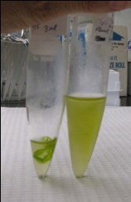
Back at the lab: 1) Check for species identification: Ulva linza is a thallus with two layers of cells, flat blades, a bit ruffled, especially away from the stipe, with edges swollen (the two layers of cells are coming apart). 2) Sort individuals, using larger specimen and those with ‘golden brown’ tips first. Cut ‘golden brown’ tips off (with a bit of vegetative green growth). 3) Rinse each tip individually in sterile seawater, blot gently to remove excess water and place on absorbent paper, keeping track of tips coming from the same thallus. 4) Place in a loosely closed plastic container, in the refrigerator overnight (the tips must retain some humidity, but not too much).
Day 2:
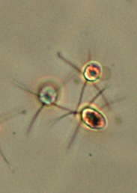
In the lab: 1) Forced sporulation: Place each tip in its own tube with 2 mL of sterile filtered seawater (keep track of volume added, if more than 2 mL is used), keep on ice at all time until ready for experiment. 2) Spore identification: Determine whether tubes contain quadriflagellated or biflagellated spores, by removing one drop of suspension, placing it on a slide with a cover slip, adding a µdrop of Lugol’s solution at the edge to stop the swimmers, and checking at the microscope. Toss out the biflagellated ones. 3) Pool all quadriflagellated cells together (keep on ice), going from the most concentrated groups first, passing them through a 90-µm sieve to remove extraneous material, until close to the needed volume. 4) Determine cell density either by enumeration at the microscope using a counting chamber or by measuring cell absorbance at the spectrophotometer at 660 nm and using the equation below. Target concentration should be close to 1 x 10⁶ mL⁻¹ (adjust with sterile seawater if necessary). 5). Rinse the labeled replicate experimental and control (clean glass) slides by dipping them 10 times in sterile deionized water, place them in ‘Quadriperm’ or Petri dishes, and evenly distribute the quadriflagellated cell suspension among the different compartments, keeping at least 5 mL for cell counts. 6) Place the dishes at 20 ºC (or room temperature) in the dark (e.g., covered with aluminum foil) overnight or up to 24-hour for incubation. 7) Note the time. 8) Add 0.05 mL of Lugol’s solution to the 5 mL of cell suspension for cell counts using a Fusch-Rosenthal or haemacytometer counting chamber. 9) Enumerate the spores (triplicates).
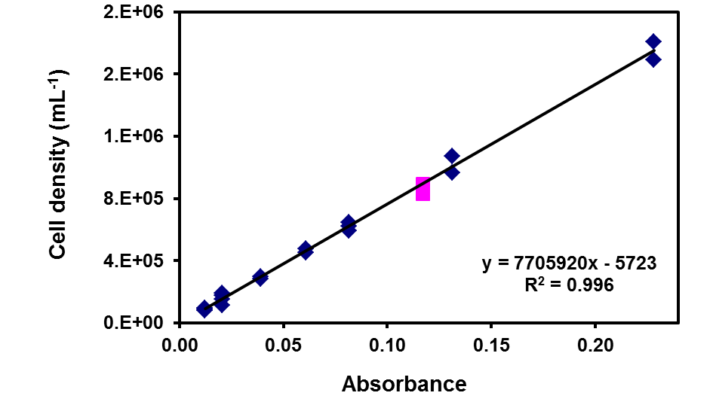

Day 3:
After incubation: 1) Retrieve the ‘Quadriperm’ dishes from the incubator. 2) Rinse all slides 10 times, back and forth one at a time, in filtered sterile seawater at 20 ºC or room temperature to remove unadhered cells. 3) In the fume hood, put slides in glutaraldehyde (1% in seawater) or Lugol’s solution for 30 minutes, transfer to filtered sterile seawater for 10 min, followed by (1 : 1) filtered sterile seawater : sterile deionized water for 5 min, by sterile deionized water for 5 min, by sterile deionized water for 5 min for a second time. Remove the slides and let them dry at an angle. Freeze (if glutaraldehyde was used) until ready for enumeration.
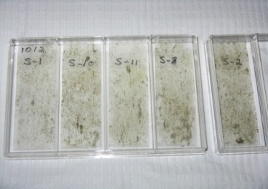
Subsequent days:
For cell counts of adhered cells, use a compound microscope with a 40X objective, counting all cells within 20 fields of view within an eyepiece with a rectangle or square reticle, along the longest axis of the slide and at intervals of about 1 mm (see suggested XL worksheet).
Ulva test
Name:
test date:
 | Per field
 | Average | # per | # per | # per | # per | # per | # per | # per | # per | # per | # per
Treatment | Response | field 1 | field 2 | field 3 | field 4 | field 5 | field 6 | field 7 | field 8 | field 9 | field 10 | etc.
Slide 1
Slide 2
Slide 3
Slide 4
Average
Control
Slide 1
Slide 2
Slide 3
Slide 4
Average
etc.

Post-lab Activities
- Data analysis: average of counting fields, average of individual slides, statistical analysis depending on the chosen experimental design (e.g., t-test, ANOVA).
- Report writing, scientific manuscript style, with discussion of results, including suggestions of additional experiments to confirm or extend results.
- Answer the following questions:
- What is the advantage for a sessile alga to release spores and gametes?
- What is the difference between a spore and a gamete?
- Do you now have different definitions for replicates and pseudo-replicates? If so, what are they?
- Pre-adhesion, how does handling material with non-gloved dirty hands affect results?
- How would you use this testing approach to investigate spore settlement under different environmental conditions? What would be your experimental design and statistical analysis?
Addendum: Using glutaraldehyde as a fixative allows for epifluorescence microscopy to facilitate enumeration. However, a dip in a dilute Lugol’s solution is safer and also possible for subsequent enumeration by light microscopy. Image analysis software can also be used if available. Fluorescence microscopy allows for testing non-clear materials.
Other possibilities for use of this technique
- Determine settlement concentration between different types of surfaces
- Look at settlement rate over time
- Determine settlement concentration on surfaces treated with a bacterial biofilm by comparison to untreated
- Establish the ratio zoospores/gametes over a season

References
Boney, A. D. 1966. A Biology of Marine Algae. Hutchinson Educational Ltd.
Callow, M. E., J. A. Callow, J. D. Pickett-Heaps, and R. Wetherbee. 1997. Primary adhesion of Enteromorpha (Chlorophyta, Ulvales) propagules: quantitative settlement studies and video microscopy. J. Phycol 33: 938-947.
Guidone, M., C. Thornber, B. Wysor, and C. J. O’Kelly. 2013. Molecular and morphological diversity of Narragansett Bay (RI, USA) Ulva (Ulvales, Chlorophyta) populations. J. Phycol. 49, 979-995.

