Northeast Algal Society
Phycology Lab Manual - ____________(title)
______________(author) - ____________________(affiliation)
Learning Objectives
By the end of this activity, students should be able to ____________(e.g., use a skill) to ___________ (e.g., learn content).
Lower level skills (e.g., to understand, to observe, to summarize, to identify) and higher level skills (e.g., to evaluate, to compare/contrast, to design, to predict) can be emphasized in the same lab activity. See Bloom’s Taxonomy example below.
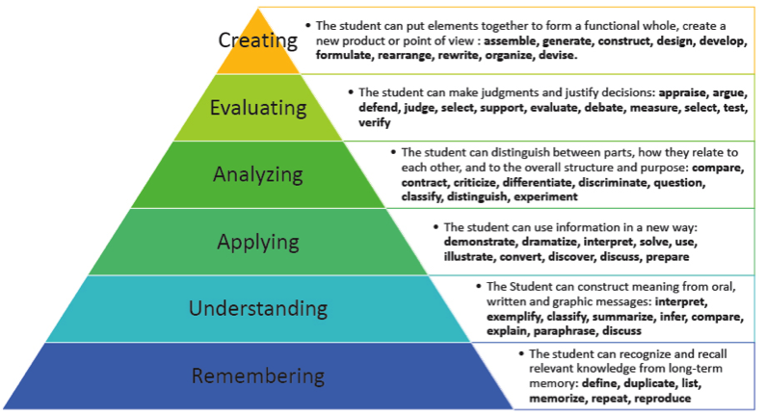

Assessment Method
A student will show they have mastered the learning objective when they can successfully complete a task using skills learned during the lab activity (called a performance-based assessment). Students should be asked to demonstrate their control of the content taught by using the knowledge in a way that reveals their understanding, not their memorization. It should be noted that if an application has been taught explicitly, and the answer is provided from memory by the student, rather than representing the presentation of a new situation, the objective assessed is factual recall, not application. Students should only be assessed on those skills which are directly relevant to the learning objectives.
Completion items (fill in the blank), Describe an application of a principle, Explain a cause-and-effect, Formulate a hypothesis/conclusion, Describe limitations of data, Explain method or procedure, Evaluate the worth of an idea, create or design something like an experiment, Develop or assess case studies or scenarios.

Instructor Notes
Materials or supplies required:
Equipment required:
Techniques required (those which are not taught during the activity but students must already have a working knowledge):
Time required:
Anticipated audience: 1) intro majors course 2) upper level majors course 3) nonmajors course 4) graduate course 5) outreach

Pre-lab Assignments
Reading assignments, pre-lab concept checks, sample quizzes similar to those which will be used during assessment

Lab Procedure
Step-by-step guidance through procedure, referencing pre-lab assignments as necessary. Lab activities should be inquiry-based when possible (e.g., utilizing a hypothesis with revisit after exploration).

Post-lab Activities
Example of assessment (test of learning objective mastery and skill transfer).

Name:
Contact information:

