Northeast Algal Society Phycology Lab Manual
Lab Activity: Reproductive ecology of Fucus vesiculosus L.: Resource allocation and gamete release.
Developed by: Dr. Jessica Muhlin, Maine Maritime Academy
Contact: jessica.muhlin@mma.edu

Learning Objectives
By the end of this field and laboratory activity, students should be able to 1) quantify the amount of biomass that is allocated towards reproduction, 2) identify the reproductive characteristics of male and female individuals, 3) understand the environmental mechanisms for Fucus vesiculosus gamete release in nature, 4) discuss the methods and results to evaluate other reproductive strategies that algae employ, as well as 5) generate experimental questions that utilize Fucus vesiculosus as a model organism.
Assessment Method
Students should be able to diagram and describe the reproductive ecology and life history of a dioecious fucoid alga. With a field-collected specimen, students should be able to sex an individual and be able to release eggs and sperm from females and males. Students should also be able to describe aspects of resource allocation, develop future experiments, and generate hypotheses on how this foundational species may respond to changes in climate (e.g., variability in storms)
Instructor Notes
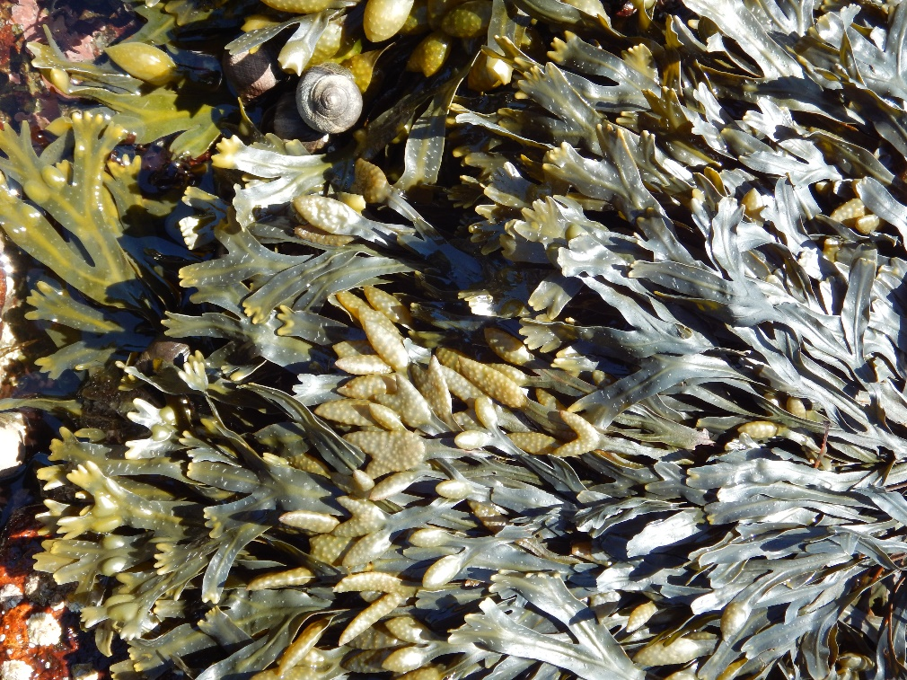
Materials or supplies required: Material of fertile male and female Fucus vesiculosus is required. The material can be collected by students if time permits or instructor can collect ahead of time. It is necessary to obtain both male and female individuals (male gametes are orange inside the conceptacles; female gametes are olive green inside conceptacles). Fucus vesiculosus is reproductive around new and full moons, September-December in the Gulf of Maine (may be shifted dependent on geographic location).
Reproductive Fucus vesiculosus in the field. The reproductive organs are called receptacles and are found at the tips of the thallus. F. vesiculosus is dioecious, meaning there are separate male and female individuals.

Equipment required: Analytical balances, weigh boats, dissecting and compound light microscopes, straight edge razor blades, microscope slides, hemocytometer (for sperm concentration), Sedgwick Rafter cell (for egg concentration), filtered seawater, ice, glassware (graduated beakers, large glass bowls), tap water, paper towels, stop watches. If there is access to a culture chamber or PAR light source (i.e., T5 bulbs, etc.) that is helpful with low light conditions.
Techniques required (those which are not taught during the activity but students must already have a working knowledge): Microscopy skills
Time required: Easiest to collect fertile male and female Fucus vesiculosus individuals at least one week prior to the reproduction laboratory. In lab, this exercise is ~3 hours (depending on the condition of the material, the light conditions, and the speed of your students)
Anticipated audience: 1) intro majors course 2) upper level majors course 3) nonmajors course 4) graduate course 5) outreach
1. Discuss the Serrão et al. 1996 research paper with students referring back to their detailed paper summary. If needed, develop additional pre-lab questions. Grade paper summary.
2. Provide background into the reproductive ecology of marine organisms with external fertilization. Characterize the reproductive ecology of Fucus vesiculosus.
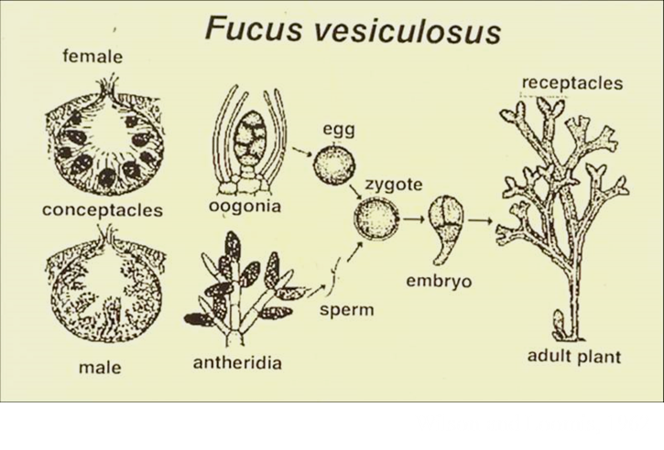
Wilson and Loomis, 1962

3. Go over the reproductive allocation protocol and gamete release protocol. Diagram out the basic anatomy of a receptacle to orient the students to what they will be seeing. For example, draw a cross-section of a receptacle, showing conceptacles
4. Have students individually work with at least one male and one female sample, following the lab procedure. All drawings and experimental observations should be completed and recorded in lab notebooks. Reproductive allocation data should be handed to the instructor at the end of the laboratory session for further/future analyses.
5. Working in teams of 3-5 students, students should pool their reproductive material together, keeping separate male and female receptacles, and osmotically shock receptacles. If it is a sunny day, place receptacles out in the bright sunlight to release gametes. If it is overcast/inclement weather, utilize culture chamber and/or artificial grow lights. If not under high light, it may take substantially longer for gamete release to occur. If no release occurs, receptacles can be blotted dry, placed in Ziploc bags, and re-shocked again (within 1-7 days).

Northeast Algal Society Phycology Lab Manual
Lab Activity: Reproductive ecology of Fucus vesiculosus L.: Resource allocation and gamete release.
Developed by: Dr. Jessica Muhlin, Maine Maritime Academy
Pre-lab Assignment: Paper summary Name: __________________________
1. Read and summarize: Serrão EA, Pearson G, Kautsky L, Brawley SH (1996) Successful external fertilization in turbulent environments. Proceedings of the National Academy of Sciences of the USA, 93, 5286 – 5290.
See Summarizing Scientific Research Articles Handout for additional guidance.
Laboratory Procedure
- Resource Allocation
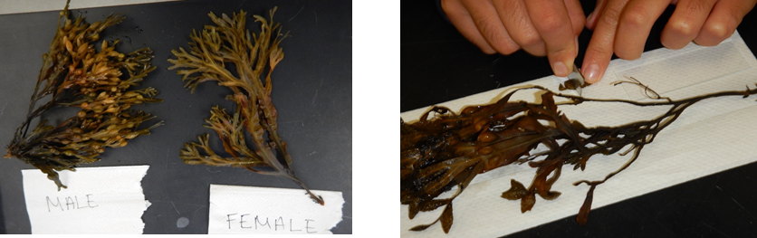
- With the fertile material collected in the field, verify that the individuals you selected are either male or female. Chose up to five specimens, carefully separating putative males from females. Taking a straight edge razor blade, thinly cross section one receptacle (see upper right photograph as an example). Place cross sectioned receptacle on a microscope slide and view under a dissecting microscope. Females will have conspicuous oogonia within their conceptacles, the oogonia being olive green in color (bottom left photograph). Males will have an orange-colored conceptacle, with antheridia (bottom right photograph). The antheridia will be too small to observe and the conceptacle will look smooth in comparison to the oogonia.
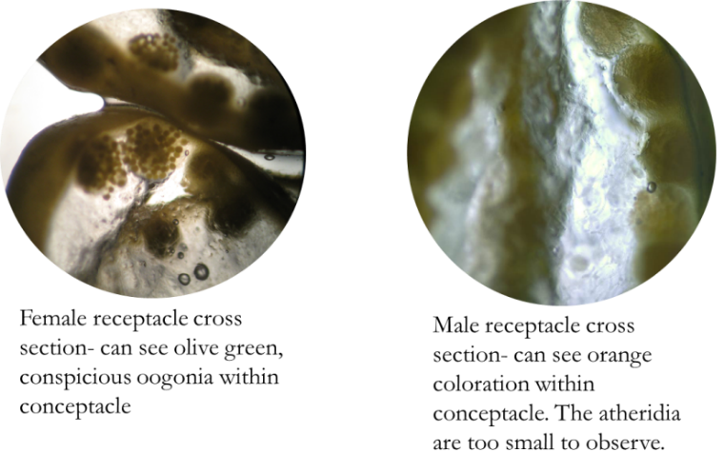
- After verifying the sex of the individuals, remove all the receptacles from each individual, keeping each specimen separate. Try to only remove the receptacle and not any vegetative tissue. Count all the receptacles for each individual, recording it on the data table (below). Weigh all the receptacles from each individual, as well as the weight of the vegetative material (the rest of the specimen that isn’t reproductive). Calculate each individual’s reproductive allocation.

Reproductive Allocation Data Table

Plant | Sex (M or F) | Verified  (check) | Number of receptacles | Weight of receptacles (g) | Weight of vegetative tissue (g) | Reproductive Allocation  (weight of receptacles)/ (weight of receptacles + weight of the vegetative tissue) x 100%
1
2
3
4
5

- Draw both male and female receptacle, identifying the epidermis, medulla, conceptacles, conceptacle pore, oogonia or antheridia. Make sure you denote the total magnification of the microscope.

- Gamete release protocol

- Place receptacles into a graduated beaker (separate beakers for each sex), filled halfway with fresh tap water. Make sure the water is cooled with ice (cold to the touch). Gently rinse the receptacles with your hands; this cleans off the mucilage and premature release of gametes. Rinse for 5 minutes. Remember to wash your hands before putting them into another beaker (don’t want to mix males with females).

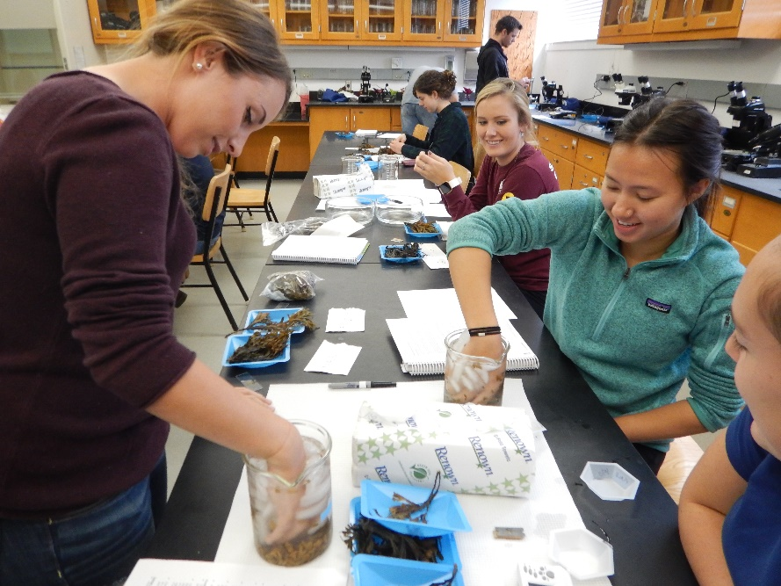

- Drain the receptacles and place onto paper towels, gently patting them dry. Leave receptacle on bench to air dry for 5 minutes.

- After 5 minutes on bench, return receptacles to beakers of fresh, cool tap water. This time, females get another 5 minutes but males get only 2 minutes. After the allotted time is up, put on paper towels again and pat dry. Leave for a further 5 minutes.

- Place the receptacles in a Pyrex dish (separate for males and females) and just cover with filtered seawater.

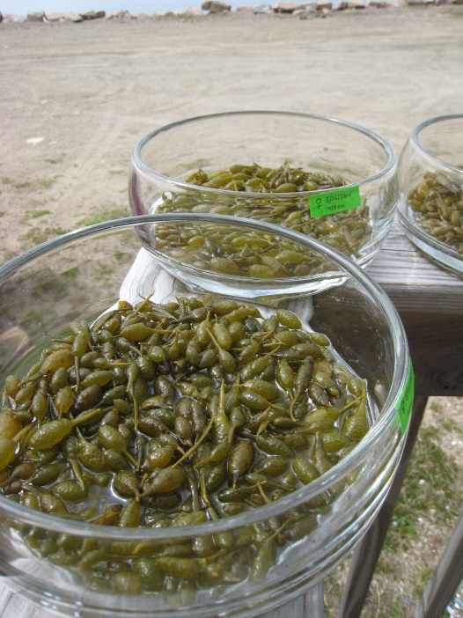
- Position the dishes either outside in a sunny location (and in another Pyrex dish full of ice to keep it cool if the weather is warm) or in the culture chamber.

- Check for release every 30 minutes. When release has occurred (you will see oogonia/eggs at the bottom the female dish and the male dish will look cloudy and be light-dark orange), take a small sample of eggs and observe under a microscope to see whether the eggs have separated or are still within oogonia. If they are still within oogonia, leave them a while longer until they separate.

- Always be careful not to cross contaminate! When you have enough material released, keep approximately 100ml of each of eggs and sperm.
Fertilization
- Take some small beakers (10ml) and fill 3/4 full of seawater. Pipet either eggs or sperm into this beaker. Let the eggs and sperm settle to the bottom of their beakers. If needed, swirl beakers to concentrate gametes into the middle of the beaker.

- For most experiments, you will want to quantify the concentration of eggs and sperm in solutions and dilute/concentrate where necessary. This allows us to calculate egg: sperm concentrations for your fertilizations. It is important not to have too many sperm, so you don’t get polyspermy (too many sperm for # of eggs=lethal for eggs) or low rates of fertilization (not enough sperm).

- Fertilizations must be done in GLASS. Sperm stick to plastic and cannot fertilize the eggs. You can do initial fertilization in small glass beakers then after 30 minutes, transfer the relevant amounts to plastic petri dishes.
Sperm: egg ratios should be between 100:1 - 1000:1; ratios of 5000:1 have approximately 20-30% polyspermy.

Northeast Algal Society Phycology Lab Manual
Lab Activity: Reproductive ecology of Fucus vesiculosus L.: Resource allocation and gamete release.
Developed by: Dr. Jessica Muhlin, Maine Maritime Academy
Post-lab Activities Name: __________________________
Answer the following questions:
1. Explain what environmental and/or biological factors are responsible for reproduction (both maturation and gamete release).

2. How might these factors influence the reproductive allocation of Fucus vesiculosus inter-annually and/or across geographic locations?

3. How might Fucus vesiculosus’ reproductive ecology change with changes in climate? Consider changes in storm events (frequency and intensity), sea surface temperature, and ocean acidification. Describe and explain those predicted changes.

4. Describe an extension to this laboratory. What experiments could you propose with an understanding of how to obtain eggs and sperm from Fucus vesiculosus? What tools and techniques would you employ to execute your experiment?

