Northeast Algal Society Phycology Lab Manual
Lab Activity: Seaweed aquaculture
Developed by: Simona Augyte, University of Connecticut, simona.augyte@uconn.edu
Lindsay Green-Gavrielidis, University of Rhode Island, lindsaygreen@uri.edu

Learning Objectives
By the end of this activity, students should be able to; (1) become familiar with the basic reproductive ecology of the three main macroalgal groups; (2) induce spore release and observe gametophyte and early juvenile sporophyte development; and (3) apply their knowledge to the initial steps of open-water seaweed cultivation; (4) evaluate the best seaweed to cultivate in a particular area; (5) understand the ecological services that aquacultured seaweed can provide.

Assessment Method
The students will show they have mastered the learning objective when they can successfully implement laboratory techniques for aquaculture seeding of several macroalgae species. They will measure and quantify the amount of viable spores available in collected material. They will test whether spore release was successful by observing juvenile thallus growth on several substrates. The students will be able to identify and compare the reproductive strategies of the different macroalgal groups (Chlorophyta, Rhodophyta, and Phaeophyceae) based on the types of spores they release; flagellated vs. non-flagellated. Overall, students will become familiar with macroalgal aquaculture practices and the importance and uses for aquacultured seaweed crops. Lastly, they will be able to combine their skills with their knowledge of seaweed reproduction and uses to assess which seaweed crops would be beneficial to aquaculture in a particular location and how seaweeds can be used to address coastal pollution.

Instructor Notes

Materials or supplies required:
Seawater (artificial or natural), reproductive seaweed tissue (to choose from the following; Saccharina latissima (sugar kelp), Ulva spp. (sea lettuce) and Chondrus crispus (Irish moss)) blades. These need to be collected prior to lab and stored in the fridge. Kelp blades can be found in the shallow subtidal on rocky shores or on beaches after storms. Ulva and Chondrus are common in tide pools and in the low intertidal to shallow subtidal on rocky shores. Ulva can also be found in estuaries and commonly washes up on beaches during low tide. For kelp and Ulva, the day before lab, reproductive tissue (*see photos) needs to be cut out, wiped clean with a paper towel and wrapped in damp paper towels overnight to induce spore release the following morning.

Equipment required:
Dissecting and compound microscopes, razor blades/scalpels, forceps, petri dishes, glass slides and cover slips, seed string, 1 L beakers, pipettes and tips for isolating spores, seawater, hemacytometer (optional)
Techniques required (those which are not taught during the activity but students must already have a working knowledge): Basic microscopy

Time required: One 3 hour lab, with a follow-up lab next week (at least 2 hrs.)
Anticipated audience: 1) intro majors course 2) upper level majors course 3) non-majors course 4) graduate course 5) outreach

Pre-lab Assignments

Required:
- Hurd, C. et al. 2014. Seaweed Mariculture. In [Eds.] C.L. Hurd, P.J. Harrison, K. Bischof, C.S. Loban. 2014. Seaweed Ecology and Physiology, 2nd edition. Cambridge University Press. pp. 551. Chapter 14, Seaweed Mariculture (pgs. 413-439)
- Redmond S, Green L, Yarish C, Kim J, Neefus C (2014) New England seaweed culture handbook-nursery systems. Connecticut Sea Grant, 93 pp. URL: http://digitalcommons.uconn.edu/seagrant_weedcult/1/

Optional (pre- or post-lab):
- Cheney D, Rajic L, Sly E, Meric D, Sheahan T. 2014. Uptake of PCBs contained in marine sediments by the green macroalga Ulva rigida. Marine Pollution Bulletin 88: 207-214.
- Schiel D.R. and M.S. Foster. 2006. The population biology of large brown seaweeds: ecological consequences of multiphase life histories in dynamic coastal environments. Annu. Rev. Ecol. Evol. Syst. 37:343–72
- Searles RB. 1980. The strategy of the red algal life history. The American Naturalist 115(1): 113-120.

Sample quiz questions:
Can you observe flagella in the spores? If so, then in which groups of macroalgae?
Life histories of the species (you can’t grow it if you don’t understand the life history!)

Northeast Algal Society Phycology Lab Manual
Lab Activity: Seaweed aquaculture
Developed by: Simona Augyte, University of Connecticut, simona.augyte@uconn.edu
Lindsay Green-Gavrielidis, University of Rhode Island, lindsaygreen@uri.edu

Pre-lab Assignments Name: ________________________
Read the two resources listed below:
- Hurd, C. et al. 2014. Seaweed Mariculture. In [Eds.] C.L. Hurd, P.J. Harrison, K. Bischof, C.S. Loban. 2014. Seaweed Ecology and Physiology, 2nd edition. Cambridge University Press. pp. 551. Chapter 14, Seaweed Mariculture (pgs. 413-439)
- Redmond S, Green L, Yarish C, Kim J, Neefus C (2014) New England seaweed culture handbook-nursery systems. Connecticut Sea Grant, 93 pp. URL: http://digitalcommons.uconn.edu/seagrant_weedcult/1/

Additional readings which may be helpful for you:
- Cheney D, Rajic L, Sly E, Meric D, Sheahan T. 2014. Uptake of PCBs contained in marine sediments by the green macroalga Ulva rigida. Marine Pollution Bulletin 88: 207-214.
- Schiel D.R. and M.S. Foster. 2006. The population biology of large brown seaweeds: ecological consequences of multiphase life histories in dynamic coastal environments. Annu. Rev. Ecol. Evol. Syst. 37:343–72
- Searles RB. 1980. The strategy of the red algal life history. The American Naturalist 115(1): 113-120.

Pre-lab concept check questions (to be completed before class)
- How can you distinguish reproductive material in the different algal groups?

- What are some benefits of seaweed aquaculture? Specifically, what ecosystem services does it provide?

- What are the main uses for aquacultured seaweeds?

Saccharina latissima (Sugar kelp) Lab Procedure

Economic Importance of Saccharina spp.
Sugar kelp has important nutrient bioextraction roles when cultivated in eutrophic water bodies like in Long Island Sound. Most of the kelp in the U.S. is wild harvested, but the kelp industry is developing to supplement demand (Redmond et al. 2014). Saccharina latissima is being cultivated in New England to use as a vegetable for human consumption, and can be used dried, powdered, fresh, cooked or frozen. It also has applications as animal feed and plant fertilizer. Alginic acid, or alginate, is a polysaccharide found in the cell walls of sugar kelp and is utilized in biomedical, laboratory, paper, textile and manufacturing industries (Redmond et al. 2014).

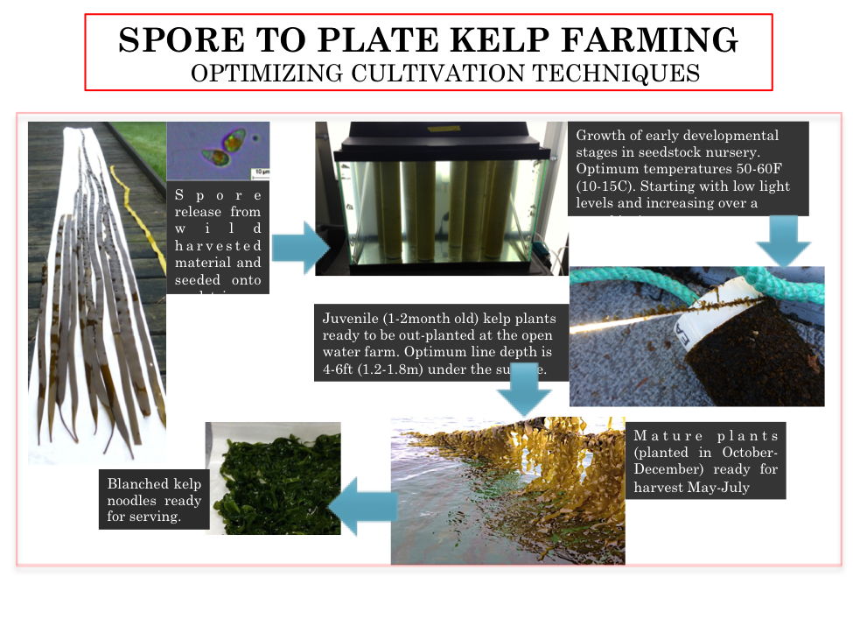
Figure 1. Overview of sugar kelp cultivation techniques.

Pre-lab preparation

Collect reproductive Saccharina blades - look for dark thick patches (sorus tissue) in the middle of blades (Fig.1). Peak reproduction occurs in the spring and fall in the North Atlantic. Once in the lab, cut cross sections through fresh sorus tissue to observe sporangia under the microscope. Cut out along the edge of the sorus to remove from the rest of the blade. Scrape tissue gently with razor blade making sure to remove any epiphytes, and then with paper towel, place in a bath of seawater and again gently scrape with paper towel. Wrap sorus tissue in a lightly moist paper towel, place in plastic bag and leave in the dark in 10°C until the following morning. Your instructor may have completed this step for you.

Lab Protocol
Second day technique
1. Obtain cleaned sorus material that was prepped the day before and immerse in a 1 L beaker of saltwater. Agitate the material either on a stir plate or with a glass rod for 1 hour.

2. After about 1 hr., observe the change in color of the water (if a lot of spores release, expect water to become cloudy, brown color). Solution can be strained through cheesecloth/filters to remove potential contamination and other bigger particles. Kelp spores are about 5-10 μm in diameter.

3. Observe the swimmer kelp spores under a compound microscope. Quantify the density of spores using a hemacytometer. Draw spores in lab notebook.

4. Pour spore solution onto glass slides or little strips of string placed into petri dishes filled with seawater. Alternatively, the spore solution can be poured into a large beaker that has seedstring wrapped around a PVC pipe. For optimal growth, expose the petri dishes or beaker to low light levels.

5. Observe in one week to see growth of filamentous gametophytes and juvenile sporophytes.

Ulva spp. (sea lettuce) Lab Procedure

Economic Importance of Ulva spp.
The Food and Agriculture Organization of the United Nations (FAO) provides a brief description of the seaweeds cultured for human consumption on their website (see http://www.fao.org/docrep/006/y4765e/y4765e0b.htm). In addition to being cultured for food, Ulva is also used as for bioremediation (i.e. to extract pollutants and/or excess nutrients) from coastal waters and in integrated multi-trophic aquaculture systems to remove fish or invertebrate derived waste from the water column. One interesting prospect for Ulva bioremediation is the removal of synthetic chemicals such as polychlorinated biphenyls (PCBs) from the environment. Cheney et al. (2014) showed that Ulva rapidly takes up and accumulates high concentrations of PCBs.

Pre-lab preparation:
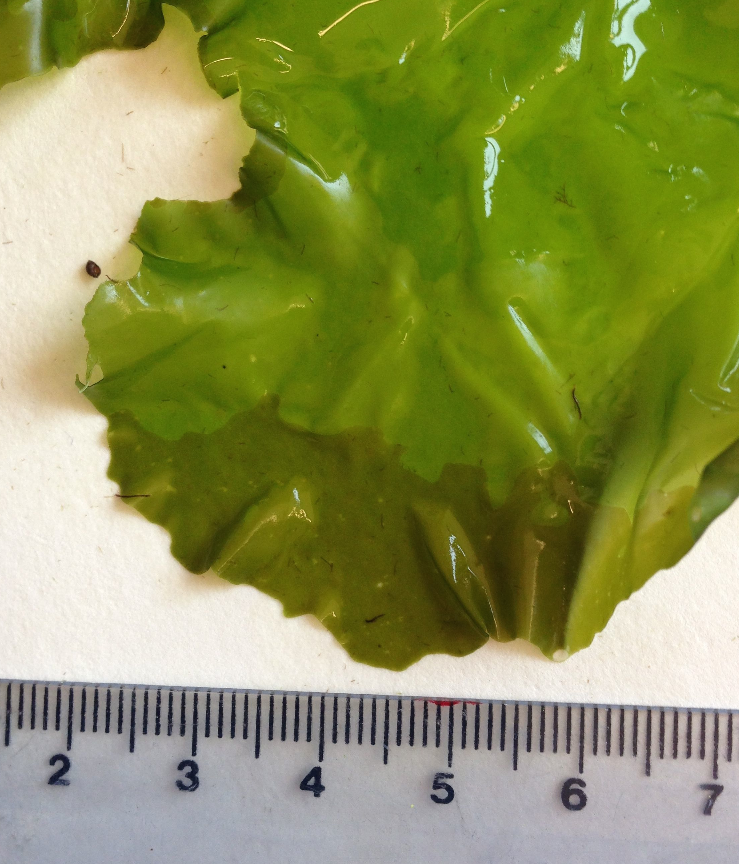
Reproductive Ulva material should be collected at least one day prior to the lab. Reproductively mature Ulva blades have dark, olive green to orange colored edges where sporangia have developed (Fig. 2). It’s ideal to collect blades the day before the lab period, but you can collect them several days ahead of time and store them in the refrigerator. Ulva species occur on rocky shores and in estuaries, but reproductive blades are more common on rocky shores. Reproduction in Ulva is tied to the lunar cycle, but the periodicity of reproduction is species specific. Therefore, go to collect at low tide in areas with cobbles/stones. Ulva blades will be found drifting, deposited on the beach, and attached to rocks.
Figure 2. Dark, olive green tinted edges are indicative of reproductively mature Ulva blades.
After material is collected, place damp blades in a Ziploc bag without water and seal it with air inside. The day before the lab, cut out the reproductive area, wrap in damp cheesecloth/paper towels, and stress for 12-24 hours in the fridge. Your instructor may have completed this step for you.

Lab Protocol
1. Rehydrate reproductive tissue in petri dishes at the beginning of the laboratory section and observe for spore release. Note: although this step generally comes after Step 2, it should be done first with prepped material to allow time for the spore to release.

2. Prepare reproductive Ulva tissue for spore release by cutting it out, rinsing it thoroughly with seawater, wrapping it in a damp paper towel, and placing it in the refrigerator.

3. After spore release, observe the spores under a compound microscope and determine phototaxis (i.e. movement of the spore in response to light). Ulva has an isomorphic alternation of generations (Fig. 3), but spore stages can be distinguished based on whether they are positively or negatively phototactic and the number of flagella. Ulva gametes are positively phototactic (prior to fusion), while zoospores are negatively phototactic. Gametes have two flagella (prior to fusion), while zoospores have four; number of flagella can be difficult to distinguish.
In order to the phototaxis of the spores, place a drop of seawater with spores on a microscope slide with a cover slip. Place the slide on the stage of a compound microscope and shine a light (using an iPhone or small flashlight) on one side of the slide while watching the spores through the objective. Determine whether the spores are swimming towards (positively phototactic=gametes) or away (negatively phototactic=zoospores) from the light. Observe Ulva spores. What type of spore do you think you have based on phototaxis? Are the spores haploid or diploid? Draw a picture in your lab notebook, making sure to note the number of flagella and other characteristics.

4. Observe the development of Ulva sporelings
  - Prepare petri dishes by filling them with seawater (with a nutrient enrichment such as a Von Stosch or Provasoli’s; see Redmond et al. 2014 for recipes) and place a couple of glass slides on the bottom.
  - Using a pipet (10-100 μL), isolate spores and spread them over the glass slides in the new petri dish.
  - Cover the dishes and place them under low light (20-50 μmol photons m⁻² s⁻¹) and a neutral photoperiod (12 hours of light and 12 hours of dark).
  - Each week, students (or an assigned group of students) should spend the first 15 minutes of class observing the development of sporelings and documenting it in their lab notebooks.
    - Look at the surface view of vegetative and reproductive cells in Ulva under the compound microscope.
    - Draw and discuss the differences between the cells in your lab notebook.
    - Make a cross section and observe Ulva sporangia.
    - Draw and discuss the characteristics you see.
  - After observation, transfer the glass slides to a new petri dish with fresh media using sterile tweezers.

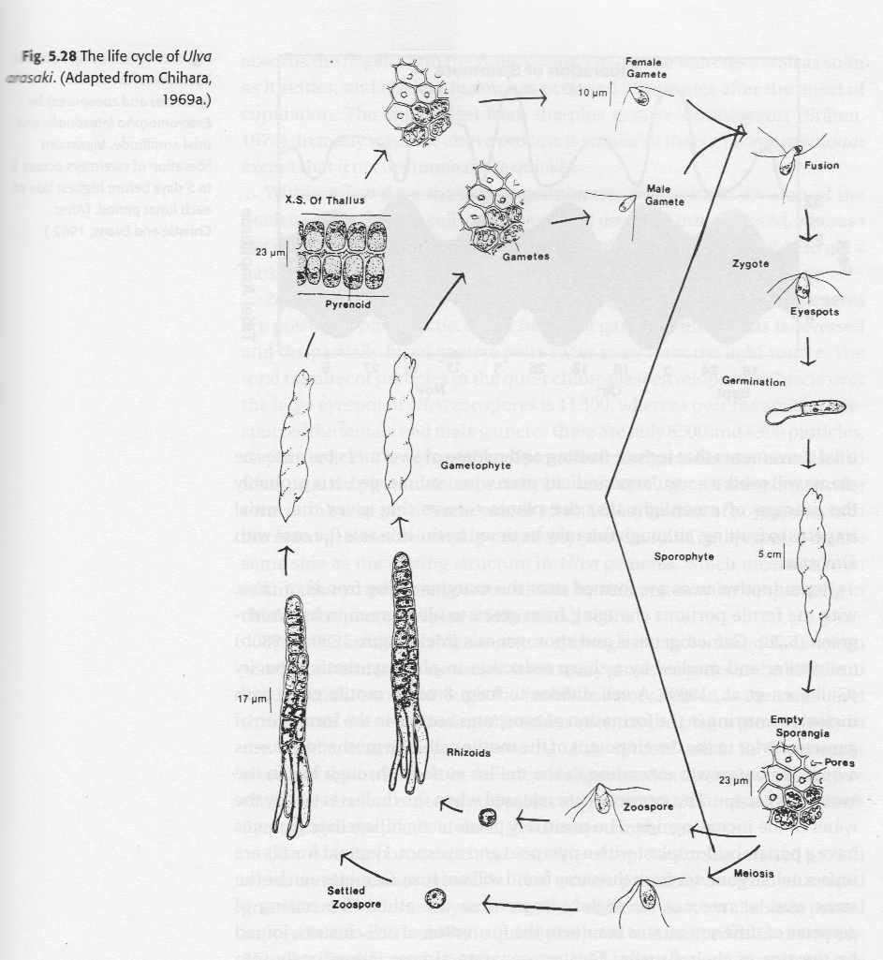
Figure 3. Life history of Ulva (Adapted by Chihara, 1969a). This example is from Phycology 3rd Edition by R.E. Lee (pg. 211). Other depictions are available on the web and in various phycology texts.

Chondrus crispus (Irish moss) Lab Procedure

Economic Importance of Chondrus crispus
Chondrus crispus is wild harvested or cultivated mainly for careegeenans, a family of polysaccharides with countless commercial uses. In Atlantic Canada, Chondrus is cultivated in tank systems by Acadian Sea Plants and sold as a multi-colored food product. There are differences in the carrageenan type present in each stage of the Chondrus life history and each type of carrageenan has unique chemical properties. Carrageenans are commonly used in instant-food products, chocolate milk, toothpaste, dairy products (including ice cream!), and in fat-free meat products.

Pre-lab preparation:
Reproductive Chondrus crispus material should be collected at least one day prior to the lab. Reproductively mature Chondrus thalli have either cystocarps (Fig. 4), which appears as bumps on the surface of that thalli, or they have tetrasporangia (Fig. 4), which appear as dark circles inside the thalli when it is held up to the light. It’s ideal to collect blades the day before the lab period, but you can collect them several days ahead of time and store them in the refrigerator. Chondrus occurs on rocky shores, in the low intertidal and shallow subtidal, and in tide pools; reproductive thalli can be found year round.
After material is collected, place damp blades in a Ziploc bag without water and seal it with air inside. Your instructor may have completed this step for you.
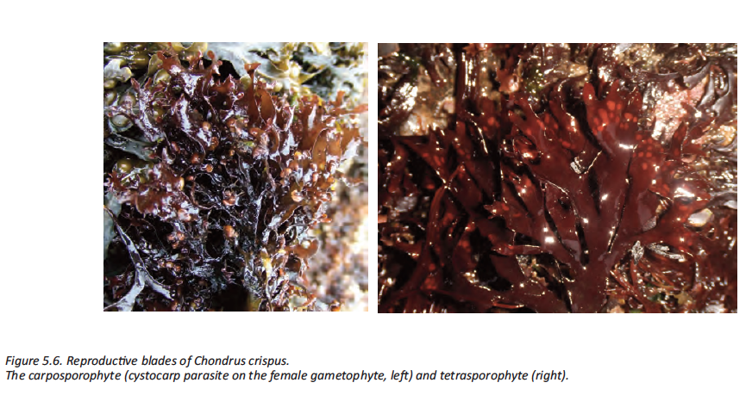
Figure 4. Left: Chondrus crispus carposporophyte (female gametophyte with cystocarps). Right: Chondrus crispus tetrasporophyte.

Lab Protocol:
1. Prepare reproductive Chondrus tissue for spore release by cutting out the cystocarps/tetrasporangia (see Fig. 5 for Chondrus life history), rinsing them thoroughly with seawater, and wiping them with a damp paper towel. The goal of this step is to remove as much vegetative tissue as possible to limit the potential that microalgae and other organism growing n the surface of the tissue will contaminate the newly established cultures during spore release. Using a dissecting microscope to help trim the reproductive material can be beneficial. Be careful when using razor blades and/or scalpels.

2. After cleaning and cutting out the reproduction tissue, place it in petri dishes with sterile seawater and observe for spore release. Note: spore release can take up to an hour. If you have not observed release within the first 45 minutes, you can manually rupture the cystocarps by squeezing them with tweezers.

3. Observe cystocarps and tetrasporangium using a dissecting microscope and draw them in your lab notebook. What type of spore is in each structure? What is the ploidy of the spores? What will each spore type develop into? After spore release, observe the spores under a compound microscope and draw their key characteristics in your laboratory notebook. What is unique about red algal spores? Why do you think they have evolved this way? (Hint: Searles, 1980).
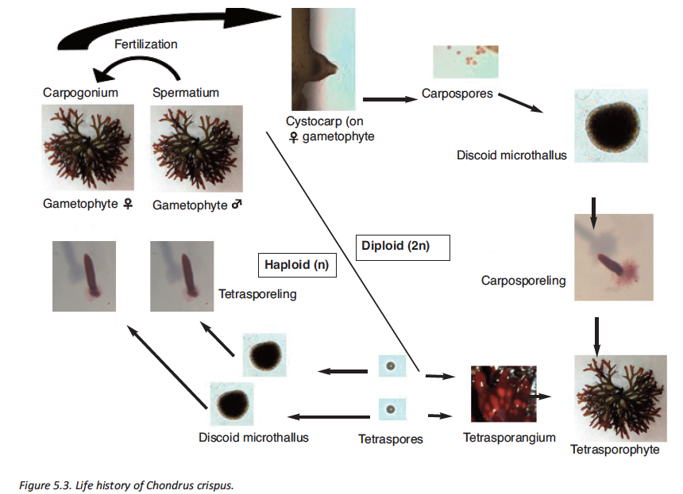
Figure 5. Tri-phasic life history of Chondrus crispus with an isomorphic alteration of generations.
5. Observe the development of Chondrus sporelings.
a. Prepare petri dishes by filling them with seawater (ideally with a nutrient enrichment such as a Von Stosch or Provasoli’s) and place a couple of glass slides on the bottom.
b. Using a pipet (10-100 μL), isolate spores and spread them over the glass slides in the new petri dish.
c. Cover the dishes and place them under low light (20-50 μmol photons m⁻² s⁻¹) and a neutral photoperiod (12 hours of light and 12 hours of dark). Chondrus generally prefers temperatures less than 15°C but will sometimes develop at room temperature. If a temperature controlled incubator is available, place the petri dishes at cooler temperatures and adjust the light levels and photoperiod of the incubator according to the above directions. Sugar kelp will also require temperatures near 10°C and can be placed in the same incubator.
d. Each week, students (or an assigned group of students) should spend the first 15 minutes of class observing the development of sporelings and documenting their development in their lab notebooks. Then the glass slides should be transferred to a new petri dish with fresh media using sterile tweezers. As Chondrus sporelings develop, look for signs of sporeling coalescence (i.e. sporelings growing together to form rafts; Fig. 6) and notice the development of the thalli.

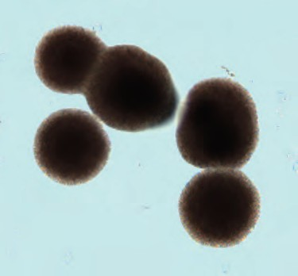
Figure 6. Sporeling coalescence in Chondrus crispus.
Post-lab Activities

Please answer the following questions in your lab notebook:

1. What steps are necessary to carry out seaweed cultivation from the lab to the open water?

2. How big is the seaweed aquaculture industry and which countries produce the most seaweed?

3. What are the economic and ecological uses of cultivated seaweeds? Name three products that you use on a weekly basis that contain seaweed or compounds derived from seaweed.

3. How can you distinguish a red algal spore from a green or brown algal spore?

4. Why do red algae have non-flagellated spores? (Hint: See Searles,1980)

5. Why do you think algal spores are phototactic?

6. Under what conditions might it be beneficial to choose red vs. green vs. brown algae to cultivate? How will this selection change under climate change scenarios?

7. Coastal pollution (e.g. PCBs, heavy metals, excess nutrients) is a major problem in many waterways in the United States. Imagine that you are an environmental consultant and are tasked with cleaning up a polluted coastal lagoon. Using your knowledge of bioremediation in seaweeds from pre-lab readings and the lab activities, develop a proposal for how to reduce pollution/remove contaminants in this lagoon.

8. You are going to start a seaweed farm! Pick a coastal location and based on the environmental variables (temperature, light and nutrient availability) of that coast, explain which species of seaweed you would grow. Be sure to explain when you would farm the seaweed (seasonality) and provide a rationale for how your farm will be successful. What product/products will you make with your aquacultured seaweed?

